**Name:** Leyan Munther Buirat

[1211439@student.birzeit.edu](https://accounts.google.com/ServiceLogin?service=mail&passive=true&continue=https%3A%2F%2Fmail.google.com%2Fmail%2Fu%2F1211439%40student.birzeit.edu%2F&Email=1211439%40student.birzeit.edu)

**College:** Faculty Of Engineering And Technology

**Major:** Bachelor Program of Computer Engineering

Basic step’s to create React Project

February 23, 2025 11:41AM

Part1: intro to crud

Api doc

Part2: init project

Bootstrap , axios , react router dom , react-hook-form

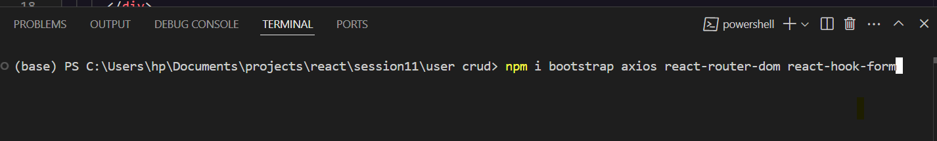

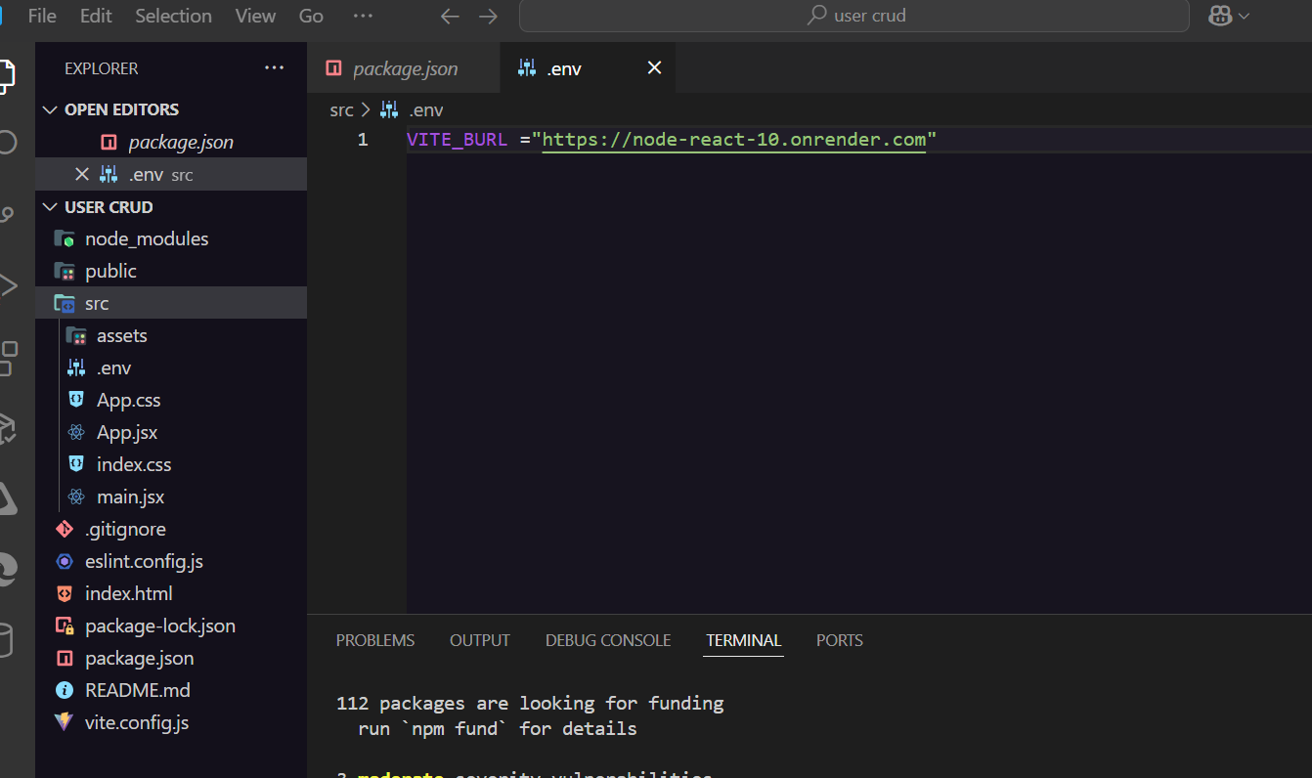

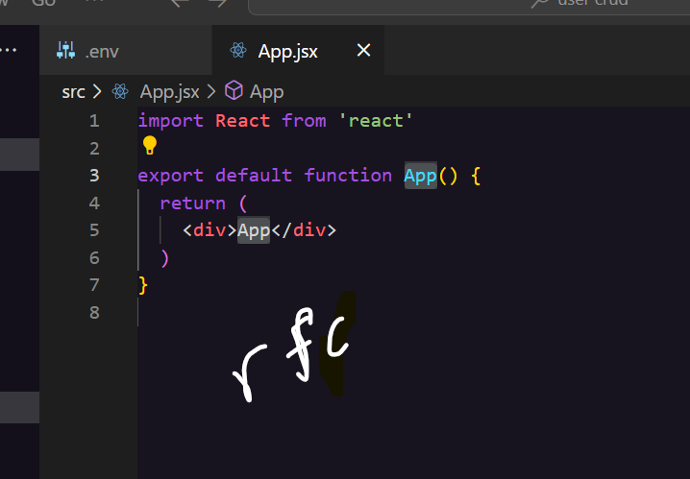

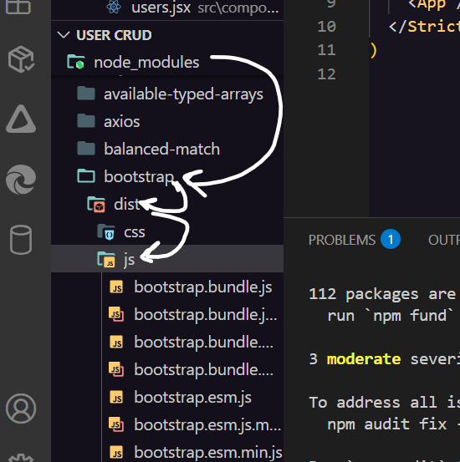

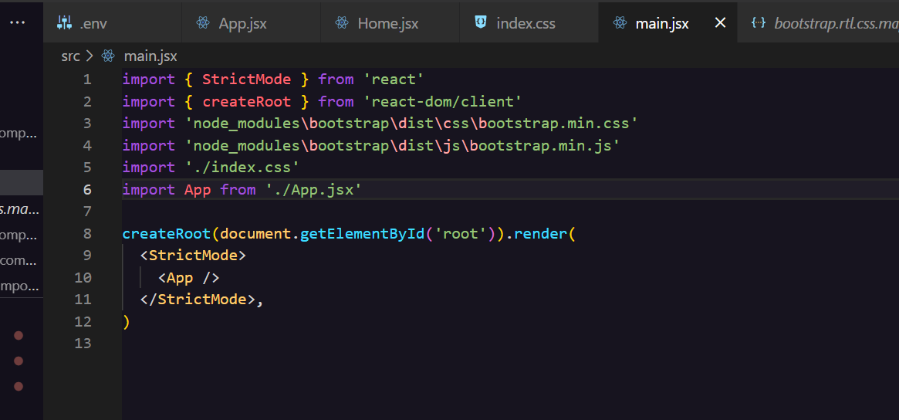

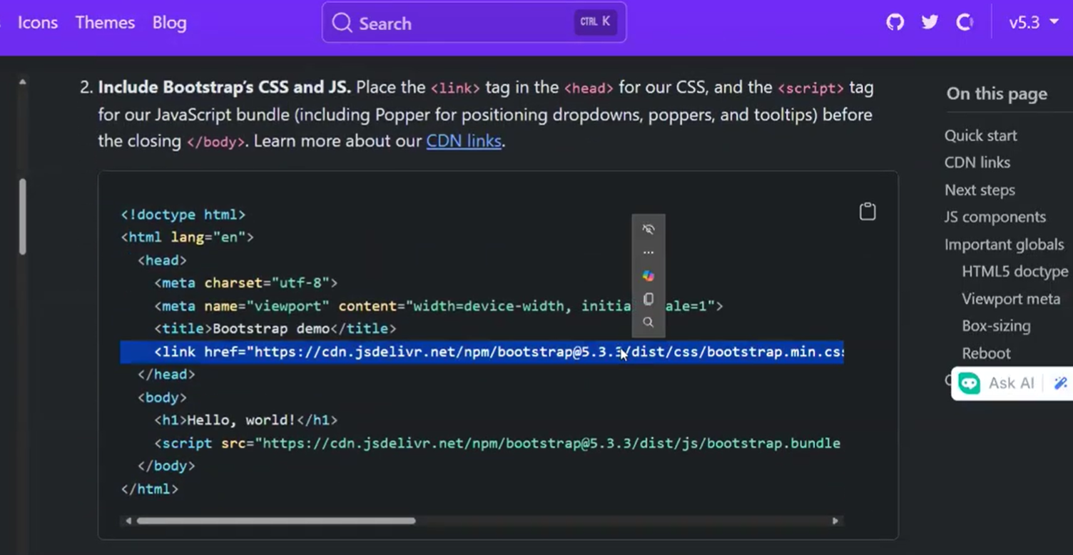<link href="https://cdn.jsdelivr.net/npm/bootstrap@5.3.3/dist/css/bootstrap.min.css" rel="stylesheet" integrity="sha384-QWTKZyjpPEjISv5WaRU9OFeRpok6YctnYmDr5pNlyT2bRjXh0JMhjY6hW+ALEwIH" crossorigin="anonymous">

[Get started with Bootstrap · Bootstrap v5.3](https://getbootstrap.com/docs/5.3/getting-started/introduction/)

BUT IT IN INDEX.HTML

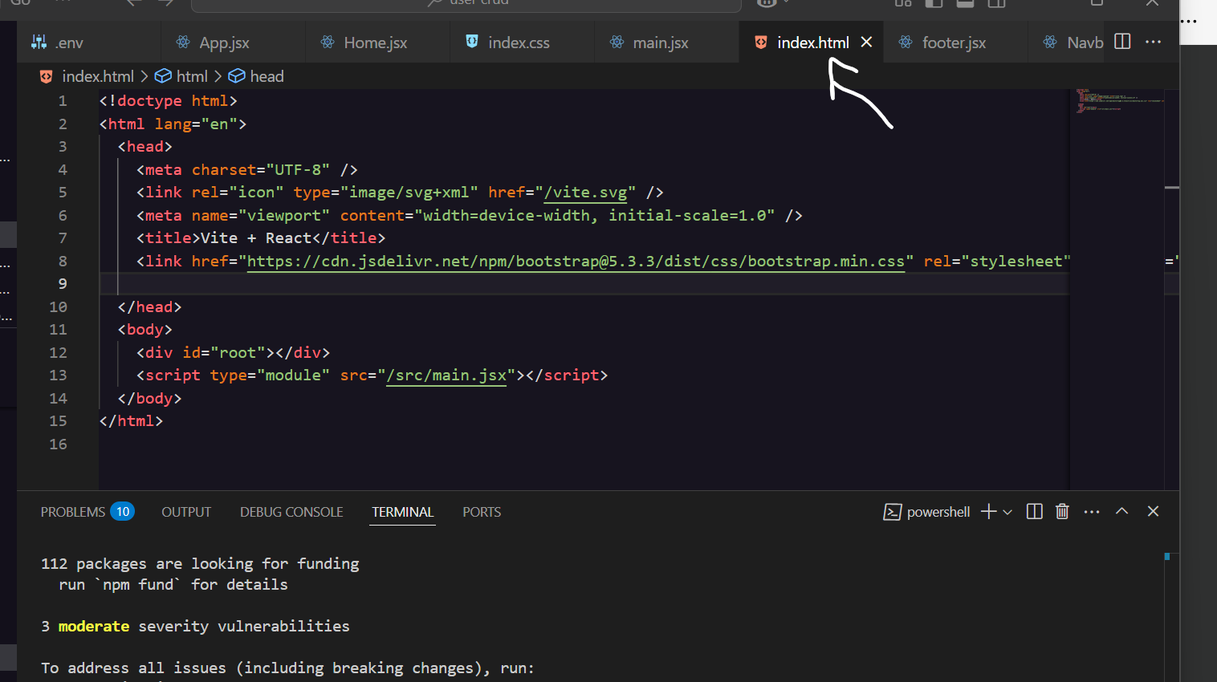

If get link CDN from bootstrap then but it in index.html will be good & work but not the best method to doit because when use it then it downloaded all libraries then take more memory so another way to do that (more better)as shown bellow figure

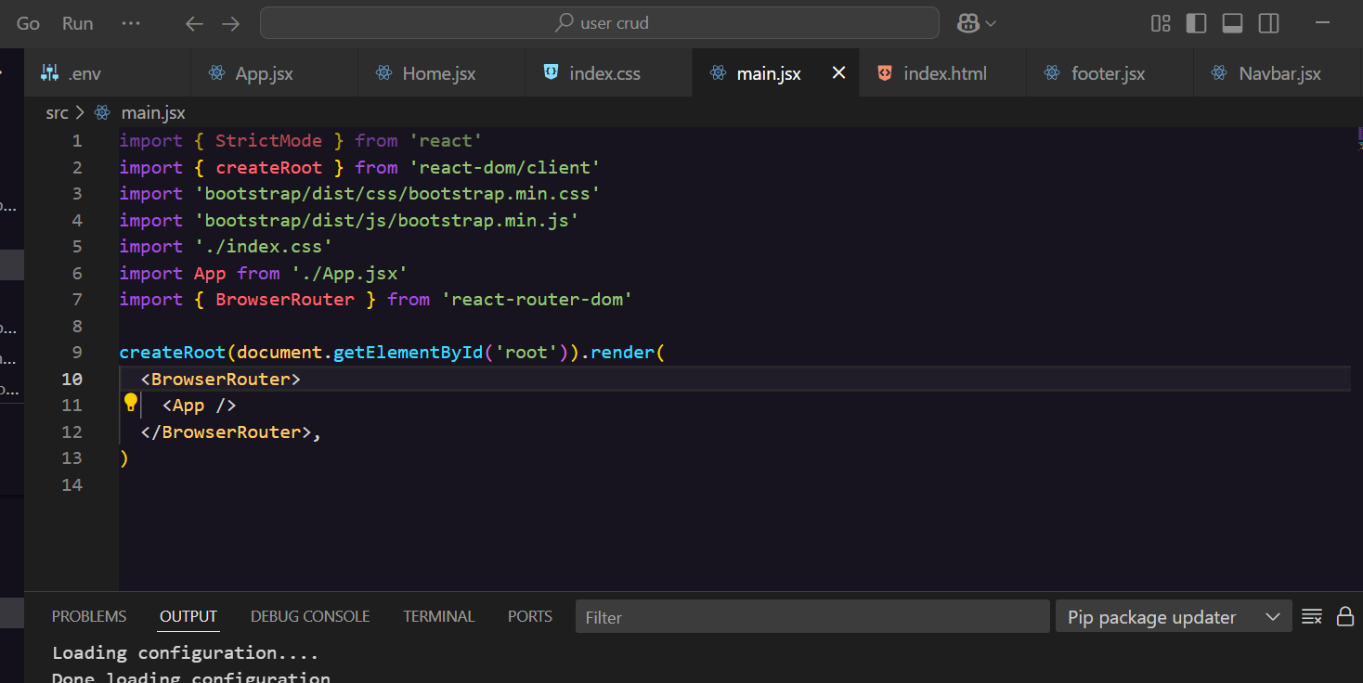

1_import 'bootstrap/dist/css/bootstrap.min.css'

2_import 'bootstrap/dist/js/bootstrap.min.js'

In main.jsx

Copy code navbar from this link:

[Navbar · Bootstrap v5.3](https://getbootstrap.com/docs/5.3/components/navbar/)

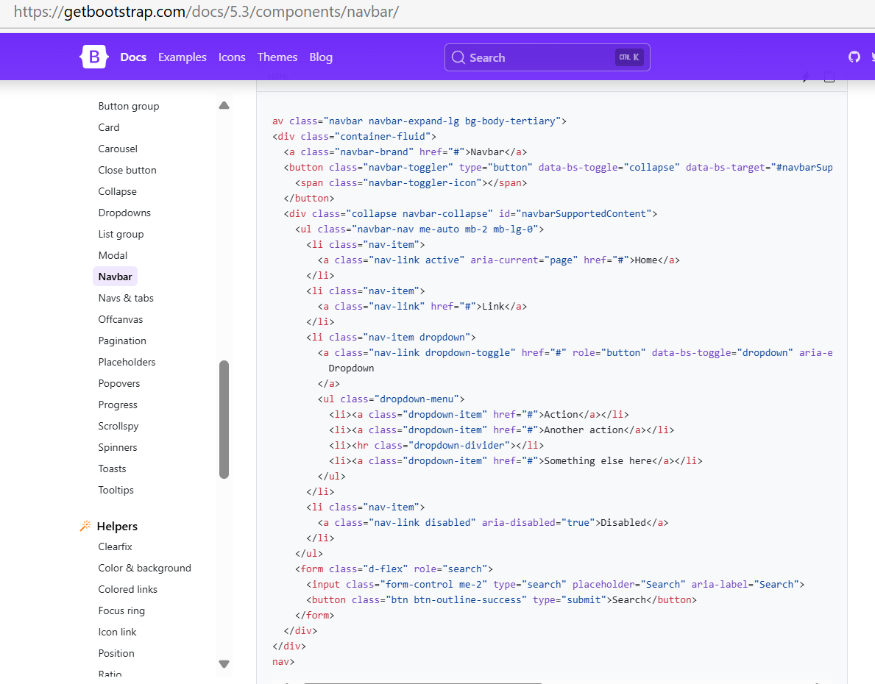

Link : L sensitive

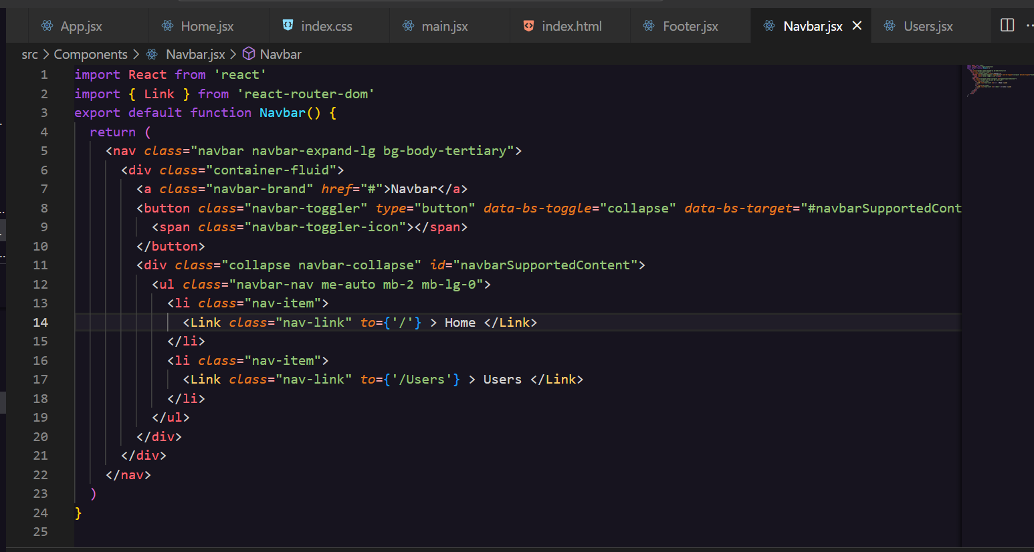

IN APP.jsx must capital characters

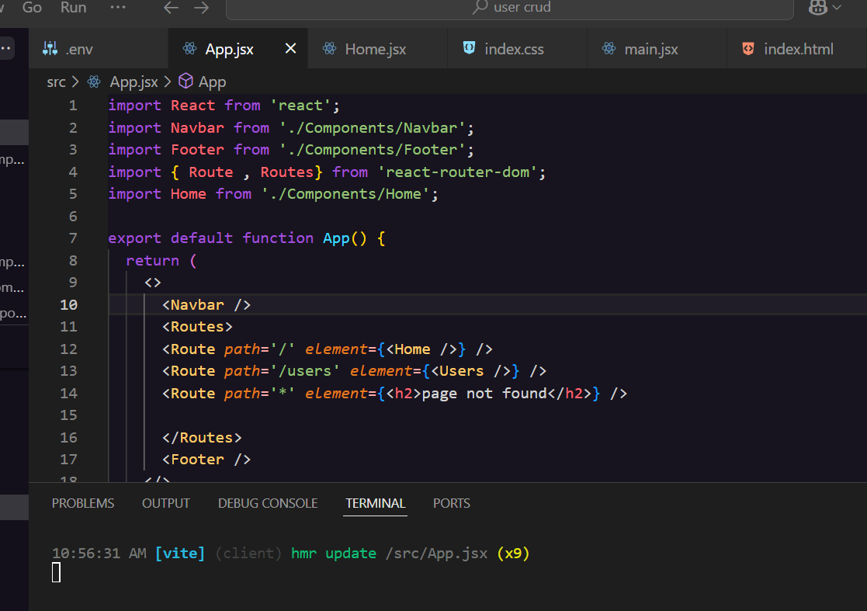

Part3: get users

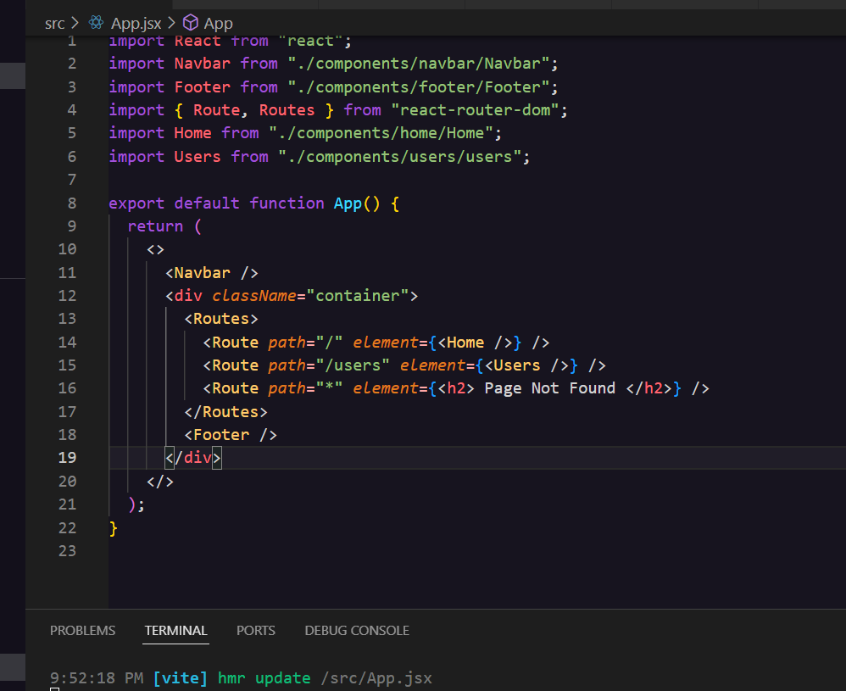

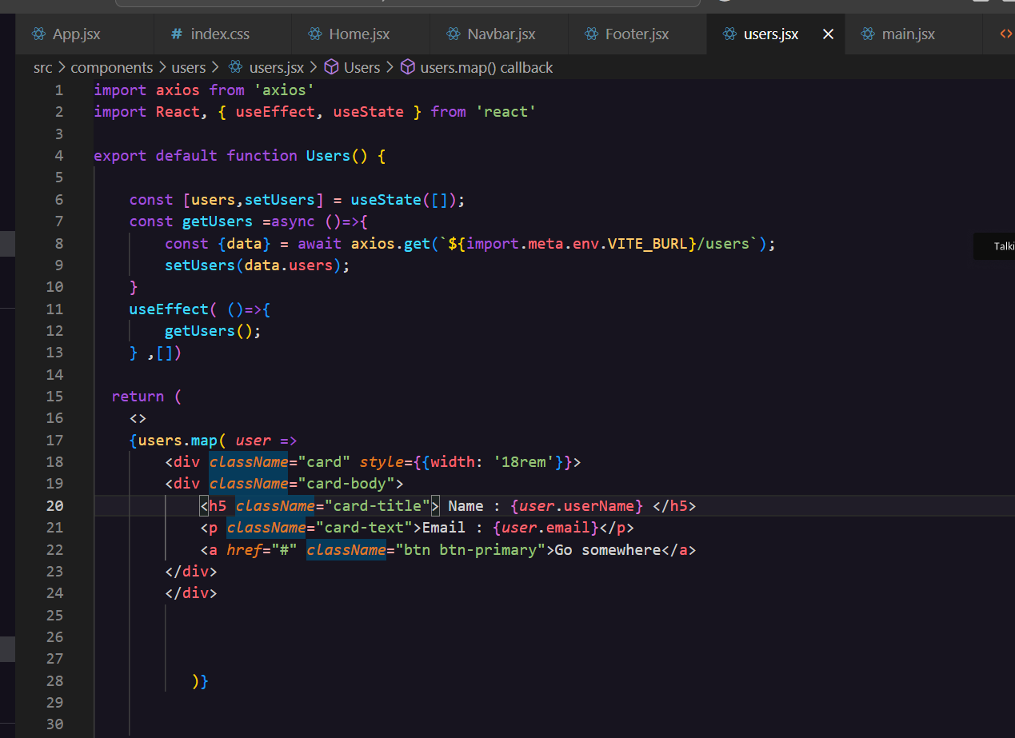

Part4 : create user

